Requirements Specification

Referral Application Recruitment



Contents

Document guide 4

Version 4

Authors 4

Project overview 5

Project description 5

Development environment 5

Product vision 6

Wireframes 6

Requirements 7

Functional requirements 7

Non-functional requirements 8

Out of scope / Bonus functionalities 9

User Personas 9

User persona 1 9

User persona 2 9

User stories 10

Recruiters 10

Employees 10

Product backlog 11

Sprint 1 11

Tasks 11

Deliverables 11

Sprint 2 11

Tasks 11

Deliverables 11

Sprint 3 11

Tasks 11

Deliverables 11

Mid-term demonstration 11

Sprint 4 12

Tasks 12

Deliverables 12

Sprint 5 12

Tasks 12

Deliverables 12

Sprint 6 12

Tasks 12

Deliverables 12

Demonstration day 12

Resources 13

# Document guide

This document provides a description to the project, it delivers an overview of the requirements and it explains the technologies used to develop the product (Why and how).

This document is written for the technology consultant Alten. Because of this it is meant to be read by employees involved in the development of this project.

# Version

|  |  |  |
| --- | --- | --- |
| Version | Date | Description |
| 1.0 | 05-09-2022 | Document creation |
| 1.1 | 12-09-2022 | Added requirements after meeting |
| 1.2 | 19-09-2022 | Added user stories and backlog |
| 1.3 | 23-09-2022 | Updated requirements based on Customer feedback |
| 1.4 | 26-09-2022 | Reviewed document with team |
| 1.5 | 03-10-2022 | Updated used technologies |
| 1.6 | 19-01-2023 | Reviewed and updated specifications based on current product and feedback |
| 1.7 | 06-02-2023 | Reviewed and updated for deliverable |

# Authors

|  |  |
| --- | --- |
| Name | Student number |
| Jeremey Sas | 1028294 |
| Michael Heerkens | 1028285 |
| Marchano Gopal | 1038165 |
| Tobias Roessingh | 1042623 |

# Project overview

## Project description

Technology consultant Alten is currently using Microsoft Excel to manage, store and overview the points that their employees can earn through multiple ways, the given examples contain: Delivering a CV = 5 points, a job interview = 10 points and a contract proposal = 20 points. These points are assigned to their employees by the recruiters of Alten.

The project is designed to take the management in Excel into a web application designed to make the usage easier and to make it possible to extend the application in the future.

## Development environment

The development environment chosen by our group is as followed:

* Front end: Vue JS + Quasar framework
* Back end: C# custom API
* Database: Postgre SQL

For more technical information, please check the technical report.

## Product vision

The vision for this product is a web application in which recruiters can manage employees, campaigns and pay out prizes to employees.

Employees can login to the system to check their score and ranking if assigned to a campaign.

### Wireframes

Down below are wireframes designed to provide an example of how the end product will look like:

#### Login page:

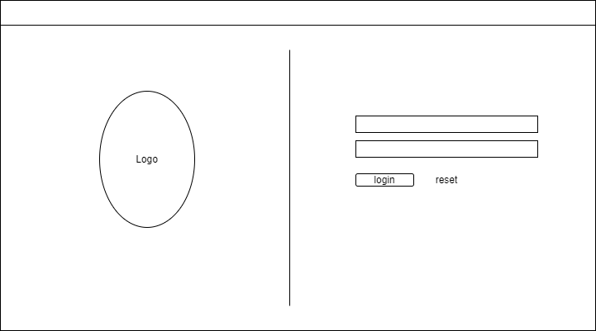

##### List wireframe:

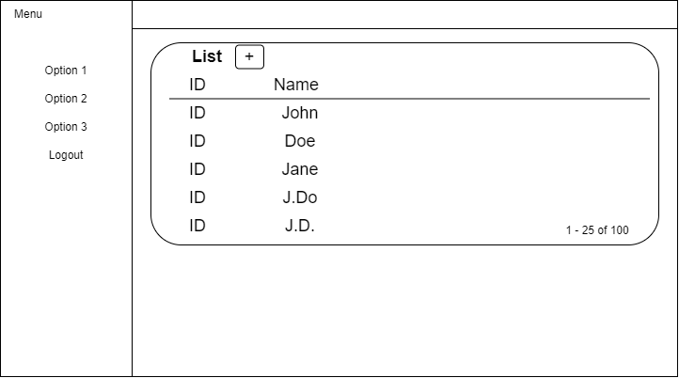

## Requirements

### Functional requirements

* Recruiters need to be able to view, edit and delete employees
* Recruiters need to be able to view, edit and delete campaigns
* Recruiters need to be able to view, edit and delete tasks
* Recruiters can assign tasks to an employee
* Employees can only view their own information
* An employee can either receive a direct prize or receive points to get a higher ranking in the campaign he is signed into.
* Employees can see their points and the ranking list of the campaign they are signed into.
* Campaigns always have a start date and can sometimes have an end date, this because campaigns are allowed to be running for a long time
* Only recruiters can pay out prizes, this because they are the only ones that can look through the entire overview
* A campaign can be configured to either pay out direct prizes or a point system on which prizes will be paid out.
* Login will be developed internally; this will eventually be migrated into the Alten Active Directory login system.
* Web application needs to be available on the entire internet (No internal network)
* Ranking lists will be displayed with points and current place
* Employees can be assigned to multiple campaigns at the same time
* The IT and Technology branches can either join the same campaign or can be split up to have the same campaign with their own branch based on the campaign configuration

### Non-functional requirements

* The web application must be available online
* The application must be able to handle the employee count of Alten (including overhead for possible new recruiters/employees)
* The web application must be responsive and work correctly on Desktop and Mobile
* The web application needs to be able to run on Chrome, Edge, Firefox and Safari
* The data must be synchronised between platforms (Windows, Apple, Android)
* The web application needs to be easily maintainable (E.g., through the use of described classes and functionalities and clear code commentary)
* The complete package is required to function as described in the Test Plan document
* Style elements provided by Alten will be used to style the application, list of provided style elements below:
  + Logo of Alten
  + Dark text being used on light / white backgrounds
  + Light text being used on coloured backgrounds
  + No effects or deformations on the Alten logo
  + Colours provided by Alten will be used:

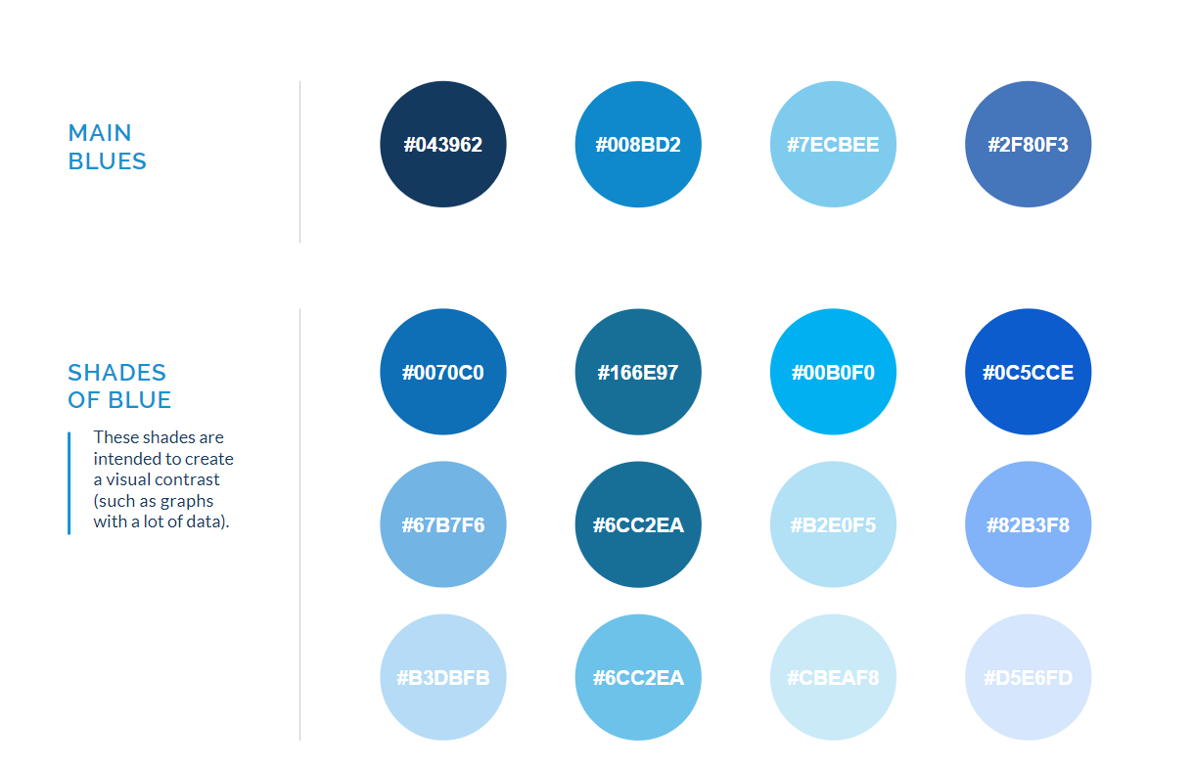

### Out of scope / Bonus functionalities

* API for data access
* Report through email
* Weekly email notifications

# User Personas

## User persona 1

* User type: Recruiter
* Occupation: Head of recruitment
* Name: John Doe
* Gender: Male
* Age: 44
* Education: HBO bachelor H.R. management specialism recruitment
* Location: Rotterdam, Noord-Holland, Netherlands
* Objective: As a recruiter I need to be able to manage scoreboards/events for employees. In active scoreboards/events I need to be able to assign points to employees who are participating in tasks/events linked to recruitment. For business management I also need to be able to create, edit and delete scoreboards/events and employees.

## User persona 2

* User type: Employee
* Occupation: Junior Consultant
* Name: Jane Doe
* Gender: Female
* Age: 36
* Education: Bachelor Business IT & Management
* Location: The Hague, Noord-Holland, Netherlands
* Objective: As an employee I want to be able to score points by completing tasks. I can achieve this by recruiting new people. I also want to see my score and place on the scoreboard to check what prizes I could receive if I recruiter more people.

## User stories

### Recruiters

* As a recruiter I need to be able to login to the system
* As a recruiter I need to be able to see a dashboard with relevant data (E.g., Employee count, count of running scoreboards/events and options menu to navigate the web application)
* As a recruiter I need to be able to view all employees registered in the system
* As a recruiter I need to be able to register new employees
* As a recruiter I need to be able to update the status of an employee
* As a recruiter I need to be able to remove employees from the system
* As a recruiter I need to be able to assign points to an employee
* As a recruiter I need to be able to send out prizes to employees
* As a recruiter I need to be able to look into all running and upcoming events/scoreboards
* As a recruiter I need to be able to create new events/scoreboards
* As a recruiter I need to be able to update the status and/or start/end dates of an existing event/scoreboard
* As a recruiter I need to be able to delete events/scoreboards from the system
* As a recruiter I need to be able to assign employees to events/scoreboards

### Employees

* As an employee I need to be able to login to the system
* As an employee I need to be able to change my personal data
* As an employee I need to be able to check my current score
* As an employee I need to be able to see my place in my scoreboard (If I am assigned to one)

# Product backlog

## Sprint 1

### Tasks

* Setup Software Requirements Specification
* Setup Click-Up Sprint board
* Setup angular web application
* Setup base C# API
* Create data model
* Communicate data model with customer
* Setup test plan based on requirements

### Deliverables

* Software Requirements Specification
* Data model

## Sprint 2

### Tasks

* Setup database
* Interface database through the C# API
* Communicate with the C# API through Angular requests

### Deliverables

* N/A

## Sprint 3

### Tasks

* Create basic authentication module
* Create employee’s business logic (Create, Read, Update, Delete)
* Execute test plan
* Document test
* Create rework document

### Deliverables

* Product package with basic authentication & business logic for mid-term demonstration
* Rework document

## Mid-term demonstration

## Sprint 4

### Tasks

* Resolve bugs documented in rework document
* Create event/scoreboard business logic (Create, Read, Update, Delete)

### Deliverables

* N/A

## Sprint 5

### Tasks

* Execute test plan
* Document test plan results
* Notify of required rework

### Deliverables

* Test plan + document of results

## Sprint 6

### Tasks

* Resolve bugs documented in rework document
* Prepare all deliverables for demonstration day
* Create video of system usage

### Deliverables

* System usage video
* Deliverables package

## Demonstration day

# Resources

|  |  |  |
| --- | --- | --- |
| Name | Type |  |
| Alten Graphic Charter | Style sheet | [Link](https://hrnl.sharepoint.com/sites/CMI-DINF2STUDIEJAAR2022-2023/Shared%20Documents/Forms/AllItems.aspx?FolderCTID=0x0120009A8CE884E723D34989E9EBBBA007C56E&id=%2Fsites%2FCMI%2DDINF2STUDIEJAAR2022%2D2023%2FShared%20Documents%2FProject%20C%2FALTEN%20Huisstijl%2Epdf&parent=%2Fsites%2FCMI%2DDINF2STUDIEJAAR2022%2D2023%2FShared%20Documents%2FProject%20C) |
|  |  |  |